ROLL NUMBER: 2420030065
EXPERIMENT 10: INSTALL AND CONFIGURE OWASP ZAP
STEPS:
- Download OWASP ZAP from the official website.
https://www.zaproxy.org/download/

2)Run the installer and complete the installation.
3)Open OWASP ZAP and start a new session.

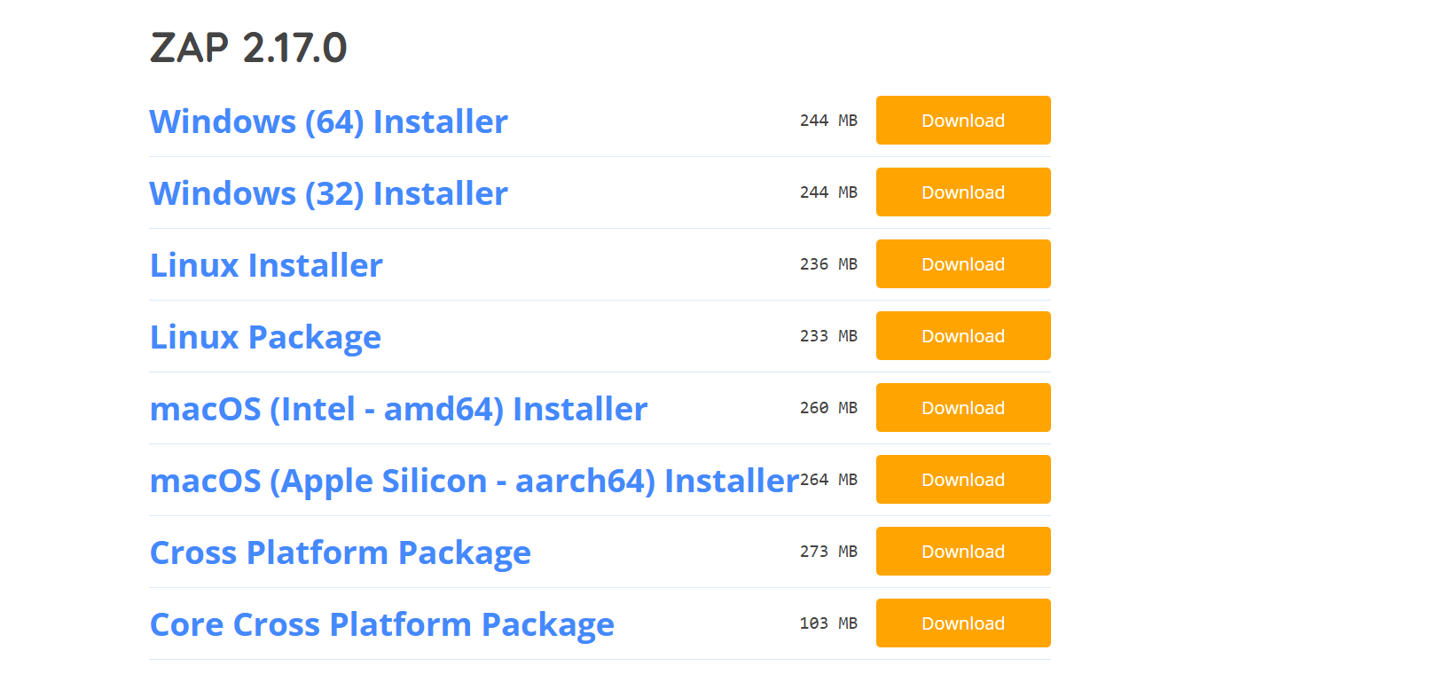
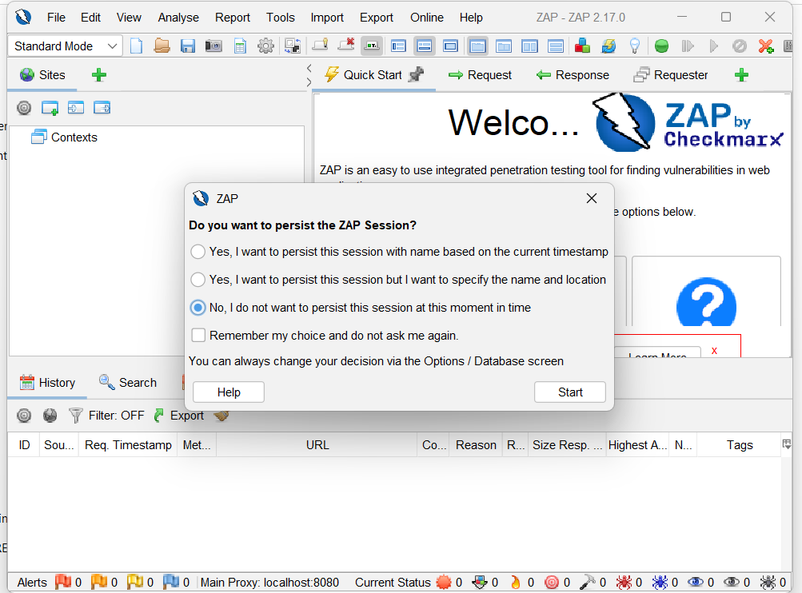
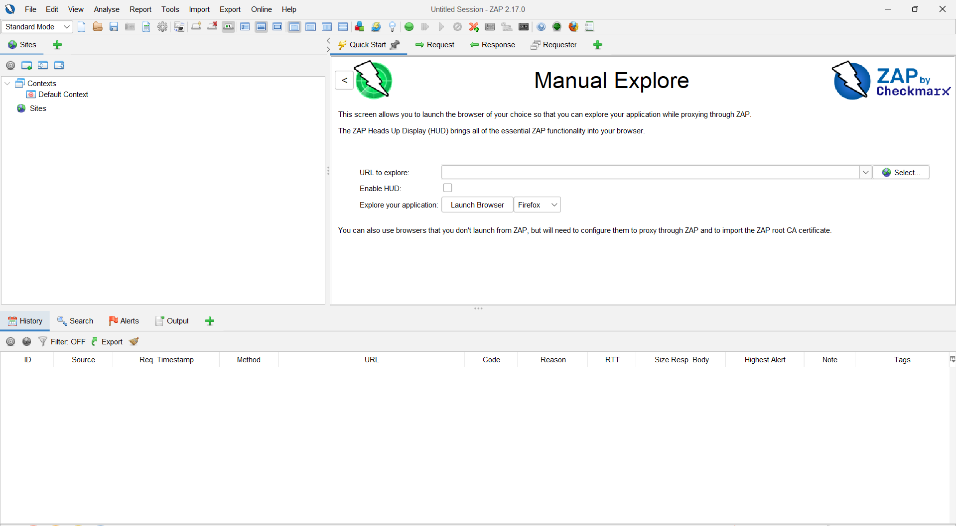
4)Observe the Sites, History, Request, Response, and Alerts sections.
5)Check the proxy address and port in ZAP settings.
6)Configure the browser to use the ZAP proxy.
7)Open an authorized test website in the browser.
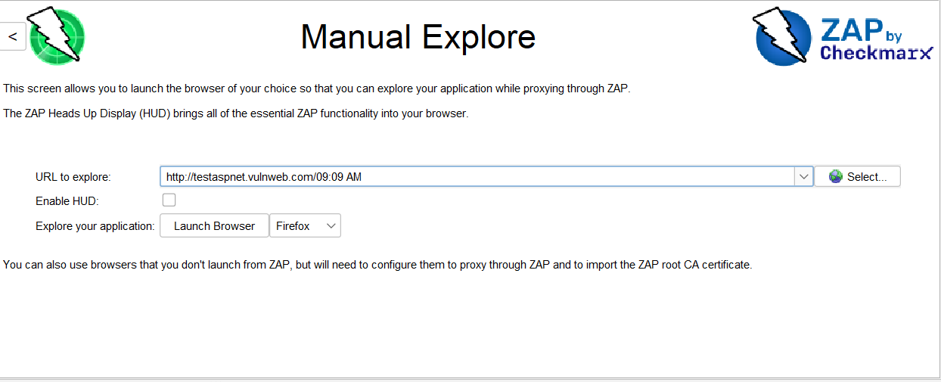
8)Check the captured website requests in the History section.
9)Observe the HTTP requests and responses in ZAP.
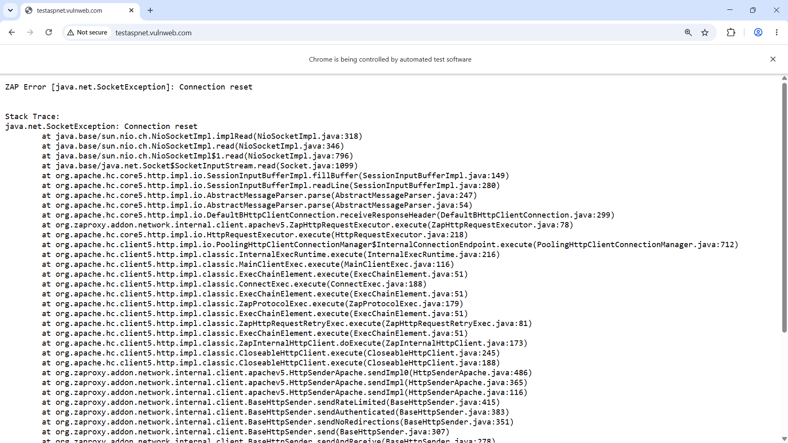
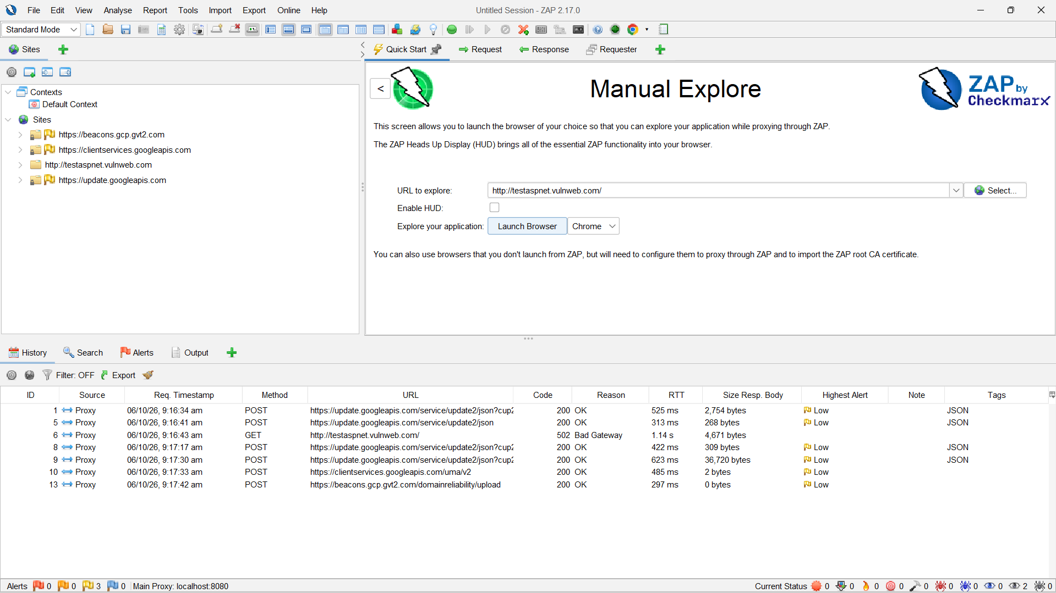
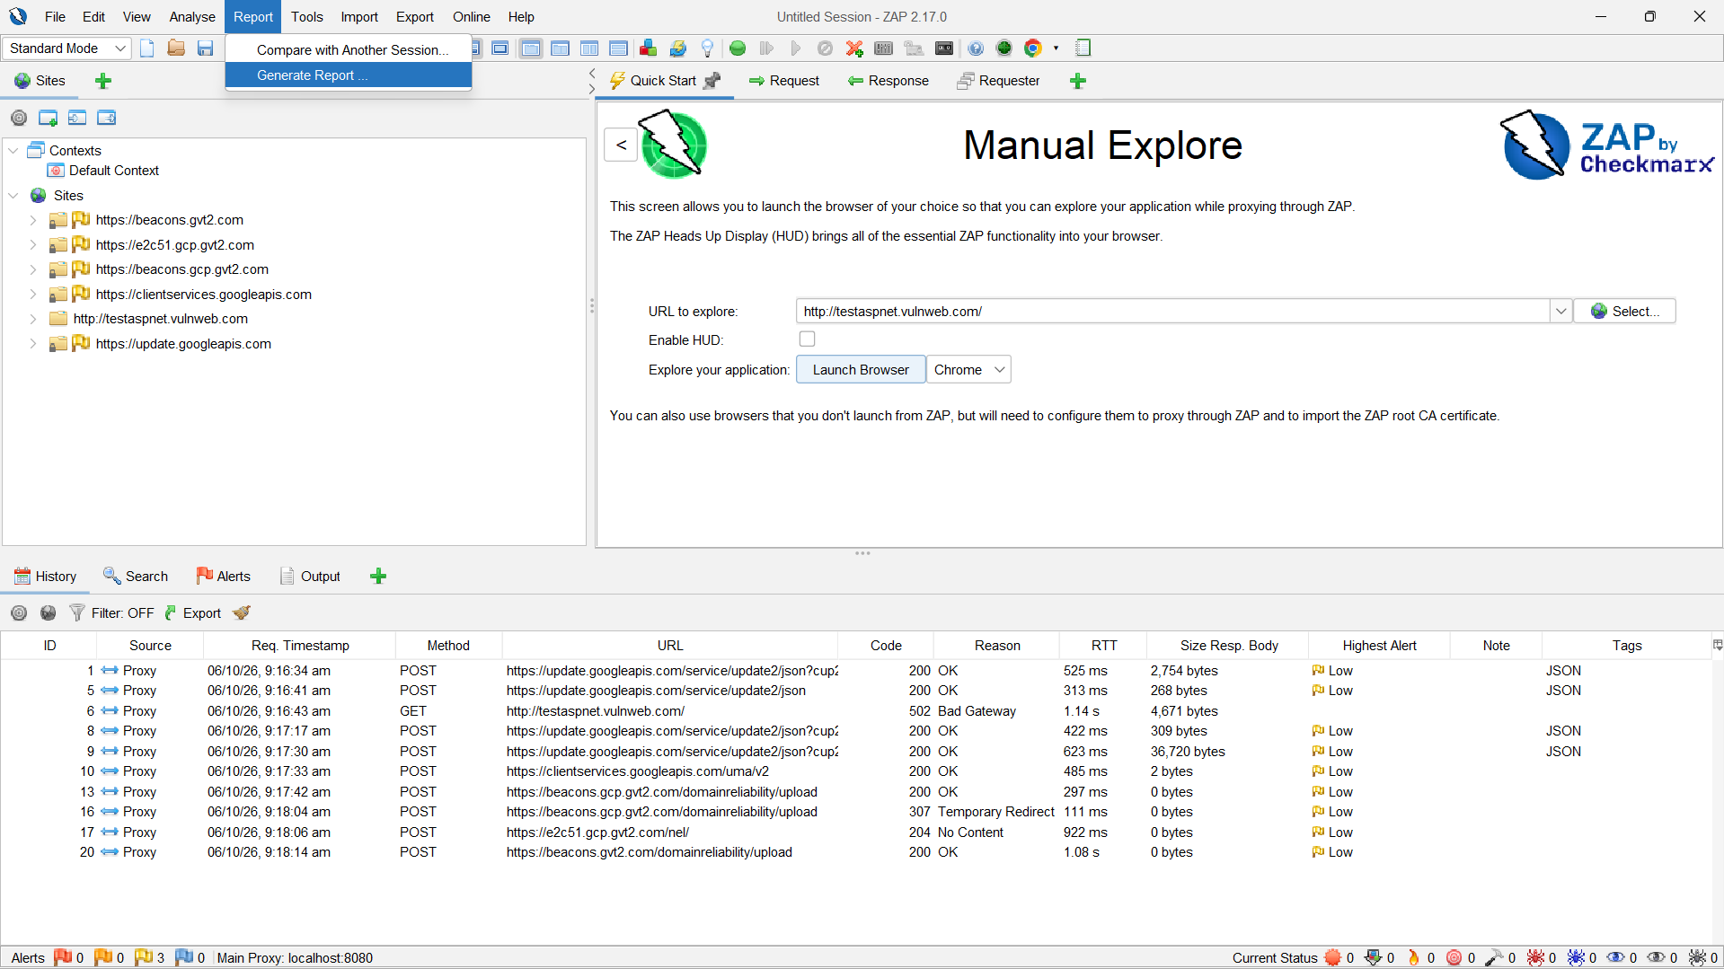
10)Open the Alerts section to view potential security vulnerabilities.
11)Generate a security report in HTML or PDF format and save it.
12)Open the report and verify the identified issues and testing results.




